Technical Interview
The following is a slimmed down version of a loan application manager. Please use the included code solution to write the functionality of the dashboard. Some of the features already work for you in the included solution. Others will need to be implemented by you. The solution uses Angular and C# (dotnet core), which is the code stack we use at GOLDPoint Systems (GPS).
Once you have completed this project and submitted your code to GPS, we will schedule an interview with you to go over your code and do a mock code review as your technical interview.
Loan Application Object Description
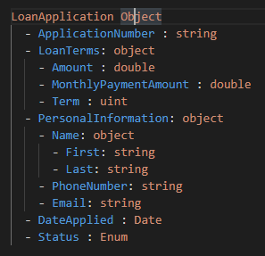
Figma Prototype
https://www.figma.com/proto/CkRwyrcEljzOjlnMEgrH5M/GOLDPoint-Interview---Application-Manager?node-id=2%3A1845&scaling=min-zoom&page-id=0%3A1&starting-point-node-id=2%3A1845

User Stories and Acceptance Criteria
Create Application
User Story 1: Create a New Loan Application
- As a user I want to create a new loan application so that I can add new applications to the DB(Json file) from the UI.
Acceptance Criteria:
- Clicking the Floating Action Button (FAB) should route to the edit application page with blank fields.
- The header should display “Create Application”.
- Fields for first name, last name, email, phone, application number, amount, term, and status should be editable and required.
- Email should validate that it is a proper email address.
- Phone should be 10 digits with no special characters.
- Changing the amount or the term should update the MonthlyPaymentAmount field (read-only).
- Status should be selectable from a dropdown with values: ‘New’, ‘Approved’, or ‘Funded’.
- Error messages should display for invalid or missing data.
- Saving should update the JSON file and display a snackbar saying “Created successfully.” Should then redirect user to dashboard.

Design Mocks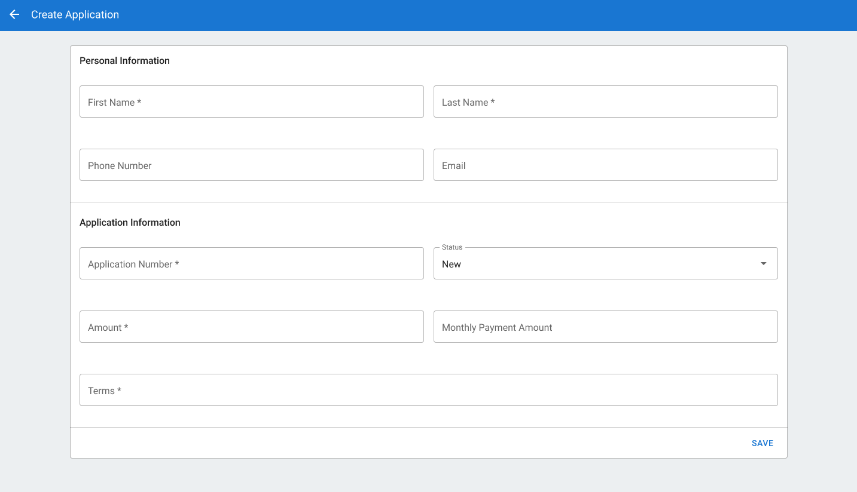
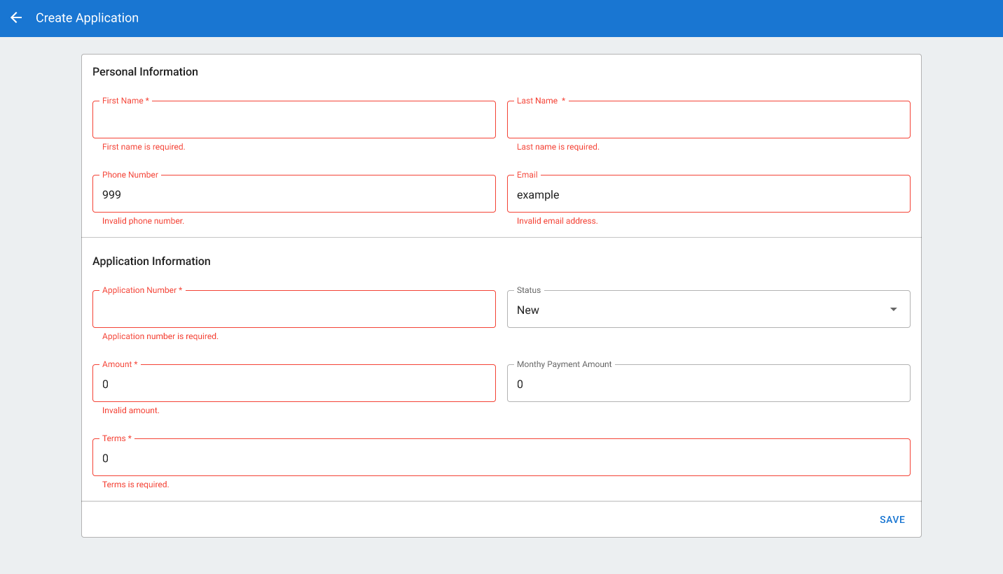
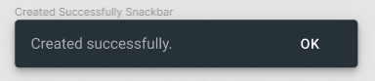

View Applications on the Dashboard
User Story 2: Display Loan Applications
- As a user I want to see a table with loan applications so that I can view the details of each application
Acceptance Criteria:
- The table should display columns: “Application Number”, “Amount”, “Date Applied”, and “Status”.
- Should get the applications from the DB(Json file).
- Each row should have a 3-dot menu icon for additional actions (edit or delete).
Design Mocks
Landing Page
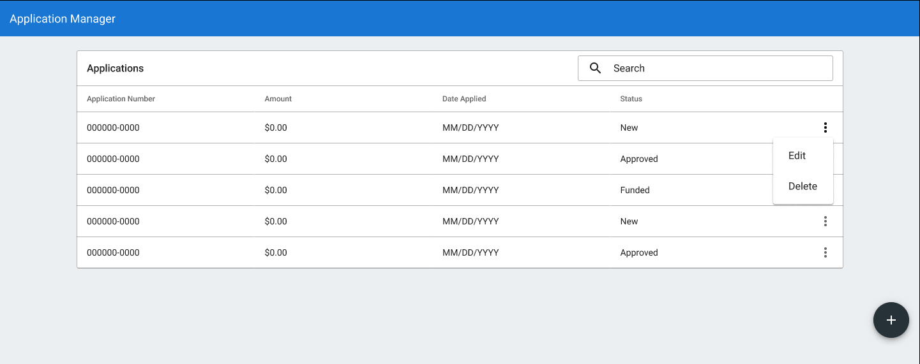

Update Application
User Story 3: Edit a Loan Application
- As a user I want to be able to edit a loan application so that I can view and update its details
Acceptance Criteria:
- A 3-dot menu icon should open a dropdown with an option to edit.
- Clicking edit should route to the edit application page with pre-filled fields.
- The header should display “Application <#>”.
- Fields for first name, last name, email, phone, amount, term, and status should be editable and required.
- Email should validate that it is a proper email address.
- Phone should be 10 digits with no special characters.
- Changing the amount or the term should update the MonthlyPaymentAmount field (read-only).
- Status should be selectable from a dropdown with values: ‘New’, ‘Approved’, or ‘Funded’.
- Error messages should display for invalid or missing data.
- ApplicationNumber should be read-only.
- Saving should update the JSON file and display a snackbar saying “Saved successfully.”

Design Mocks
Edit Application
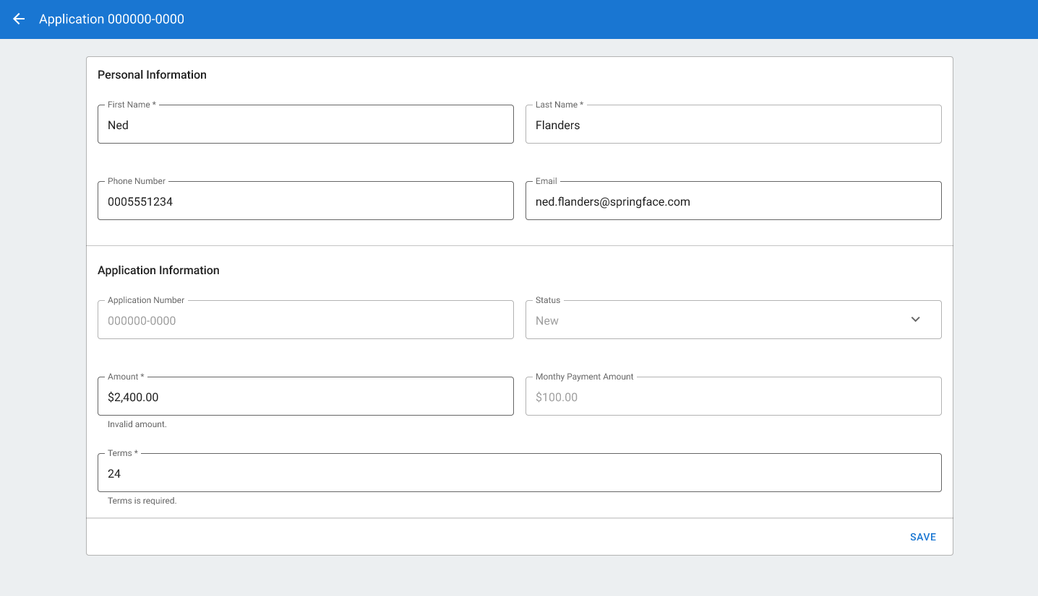
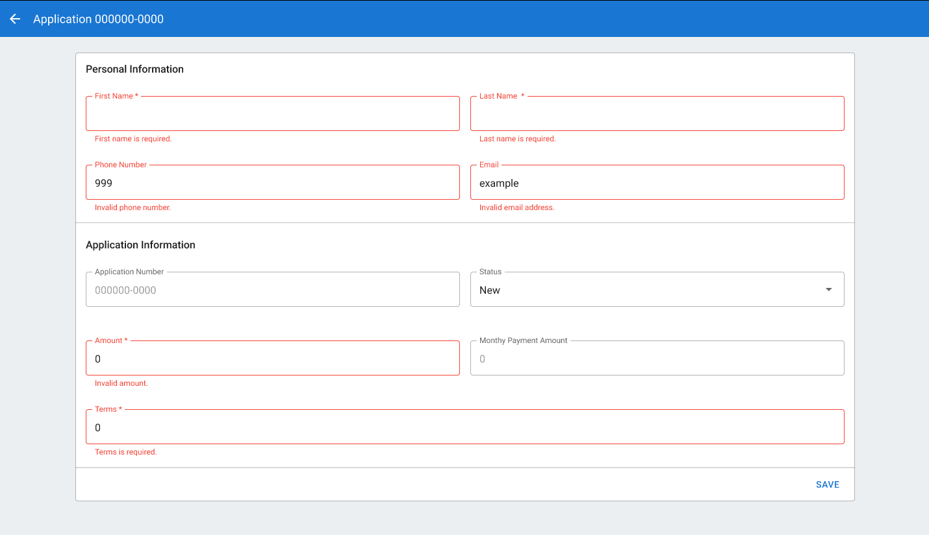

Delete Application
User Story 4: Delete a Loan Application
- As a user I want to delete a loan application so that I can remove unwanted applications
Acceptance Criteria:
- A 3-dot menu icon should open a dropdown with an option to delete.
- A confirmation dialog should appear before deletion.
- Deleting an application should remove it from the table and update the DB(JSON file).

Design Mocks



